- Purpose
  - The purpose of this document is to describe the procedure for assembling the Vac Motor on the Genesys Machine.
- Scope
  - This SOP applies to all equipment assembly team members. The process applies to the following machine ID’s:
EP50328EQS0600BE1200 – Recovery Tank Assembly (MSAS)
EP50290EQS0600BE1200 – Recovery Tank Assembly (G20)
- Responsibilities
  - The operations manager/supervisor is responsible for enforcing this SOP.
- Materials
  - The proper materials needed for this process are listed on the machine work order.
- Definitions

- Procedure
  - Take a vac motor (E28581-MSAS / E28993-G20) and place a gasket (E28608) onto it in the appropriate location.
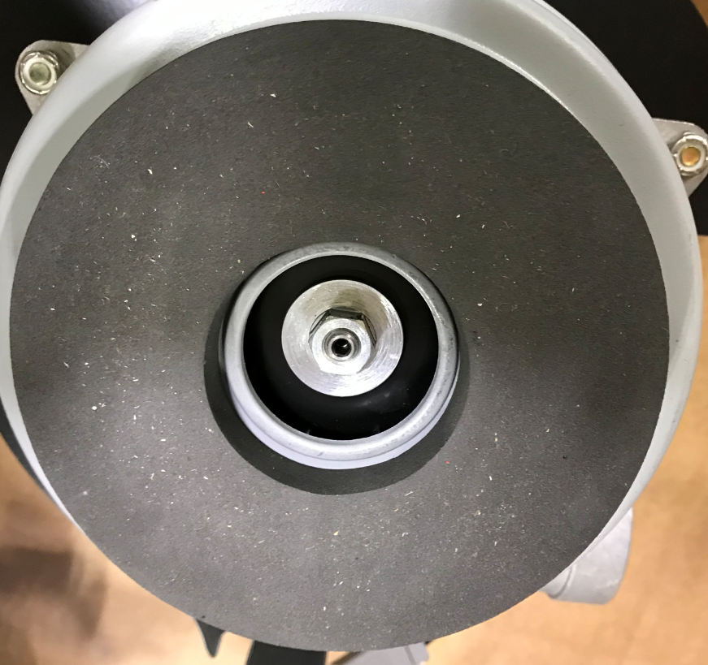
  - Take 3 isolators (E29524 – MSAS / E28914 – G20) and put a straight line on each as shown. Note: the isolators are slightly different between the two machines. The photo is for reference only.

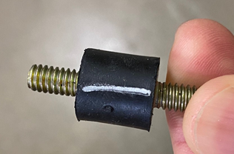
  - Place the stud end of the isolator into each of the 3 mounting holes on the vacuum bracket (E29523 – MSAS / E28995 – G20). Attach the isolators with a hex nut (E29565). Hold the isolators with vise grips or channel locks to prevent them from spinning. Tighten the nuts with a nut driver or non-impact tool.

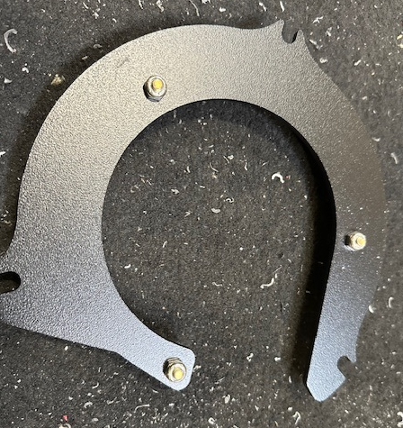

  - Place the vac mount bracket with the isolators onto the vac motor in the proper orientation. On the MSAS, attach it with 3 more hex nuts (E29565). For the G20, attach it with 3 bolts (10734). Hold the isolators with vise grips or channel locks to prevent them from spinning. Tighten the nuts with a nut driver or non-impact tool.

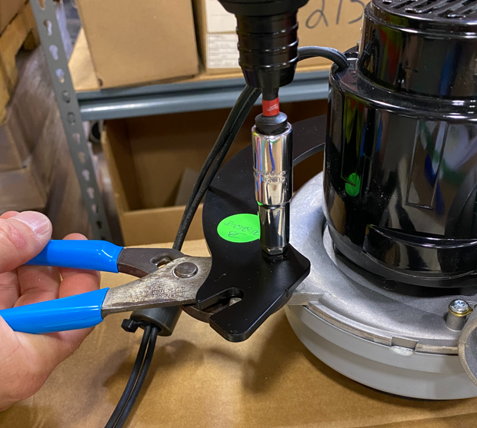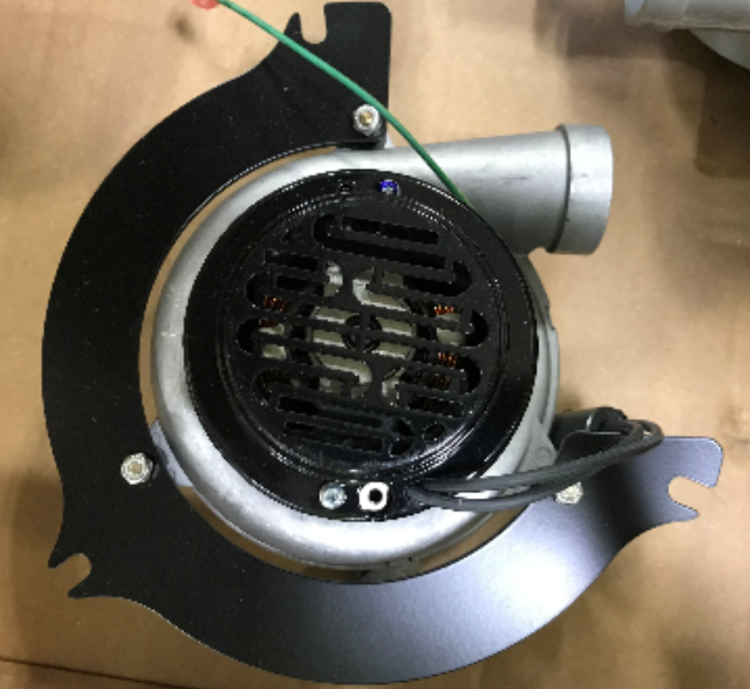
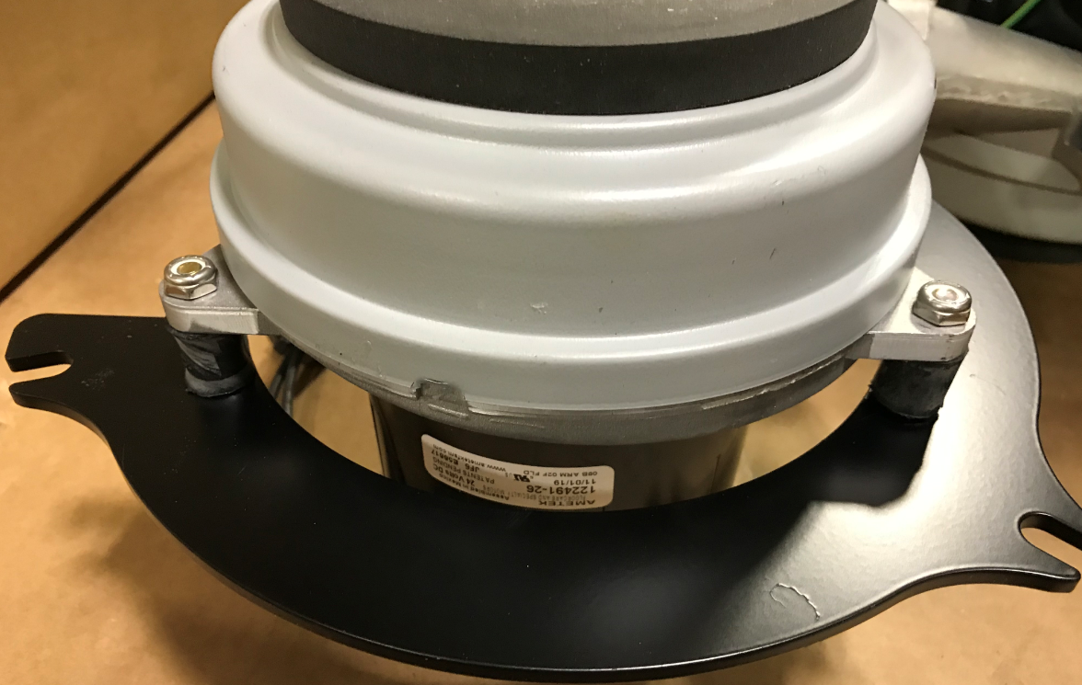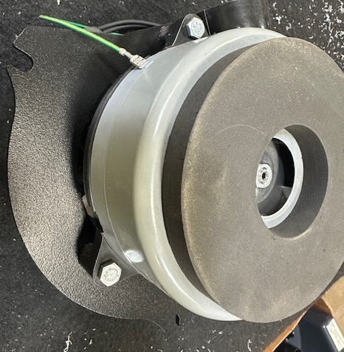
G20
MSAS

  - Ensure that the nuts are not tightened so much that the isolators twist. This will cause a failure. Make sure the lines that were put on them are straight after assembly is complete.

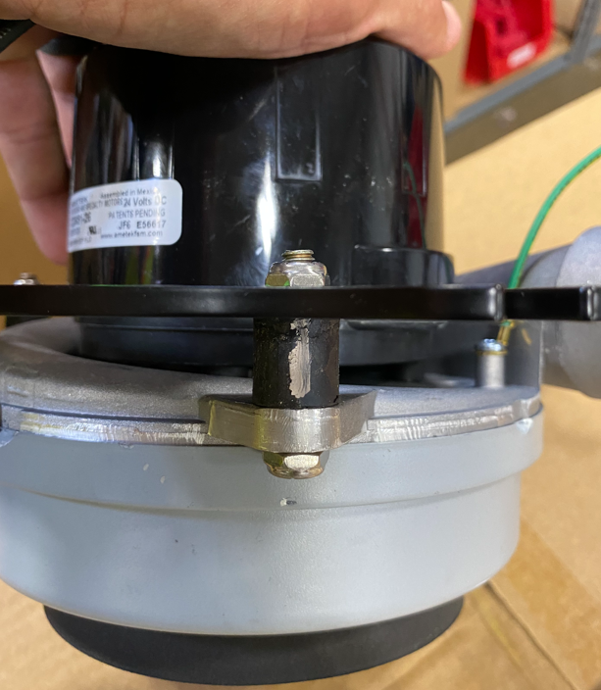

- References (optional section as needed)

- Training Guide

Functional Training Groups Requiring Training
Equipment Assembly Group

- SOP Change Control

Date of Change | Reason for Change
Rev 01 | This is the first version of the S.O.P. hence there are no revisions to this document.
Rev 02 - 3/31/2025 | Combined MSAS and G20 Instructions. Updated accordingly

Approvals

Submitter/Author Approval:__________________________________ Date:______________________

Management Approval:______________________________________ Date:______________________

QAU Approval:_____________________________________________ Date:______________________

